Apply filters to SQL queries

Project description
My organization’s goal is to maintain secure and up-to-date systems. My job is to maintain the system’s safety, investigate any potential security issues, and provide updates to employees computers as needed. These are some examples of how I used SQL filters to accomplish my tasks.

Retrieve after hours failed login attempts
A possible security incident came up after business hours (18:00) I needed to investigate all after-hours login attempts.
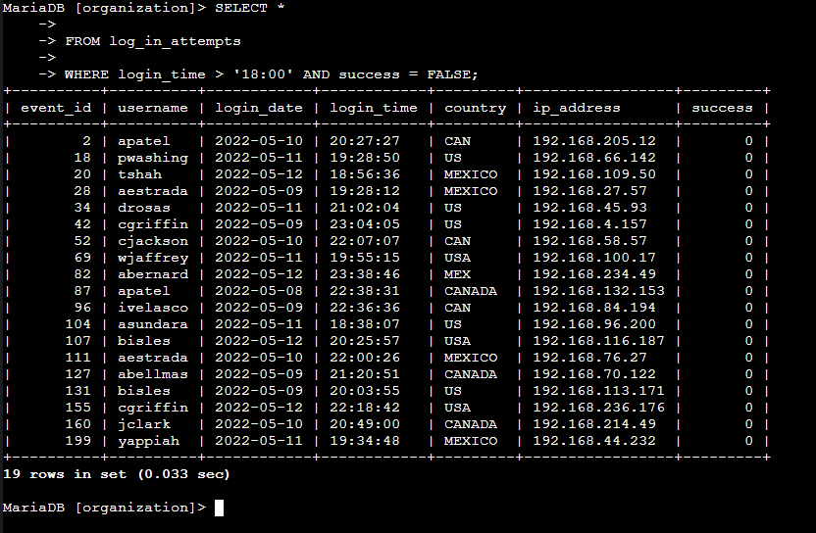

The above screenshot shows my SQL query and it’s output. This will filter any login attempts that occurred after 18:00. First, I selected all data from the log_in_attempts table. Then I added a WHERE clause with an AND operator to filter to my results to only login attempts that occurred after 18:00 and were unsuccessful.The first condition is login_time > '18:00', which tells SQL to fetch all logins that were after 18:00. The second condition success = FALSE, filters for the failed login attempts.

Retrieve login attempts on specific dates
The organization had a suspicious event occur on 2022-05-09. I need to investigate any activity that happened. The following demonstrates my SQL query used to filter for those dates and it’s output.
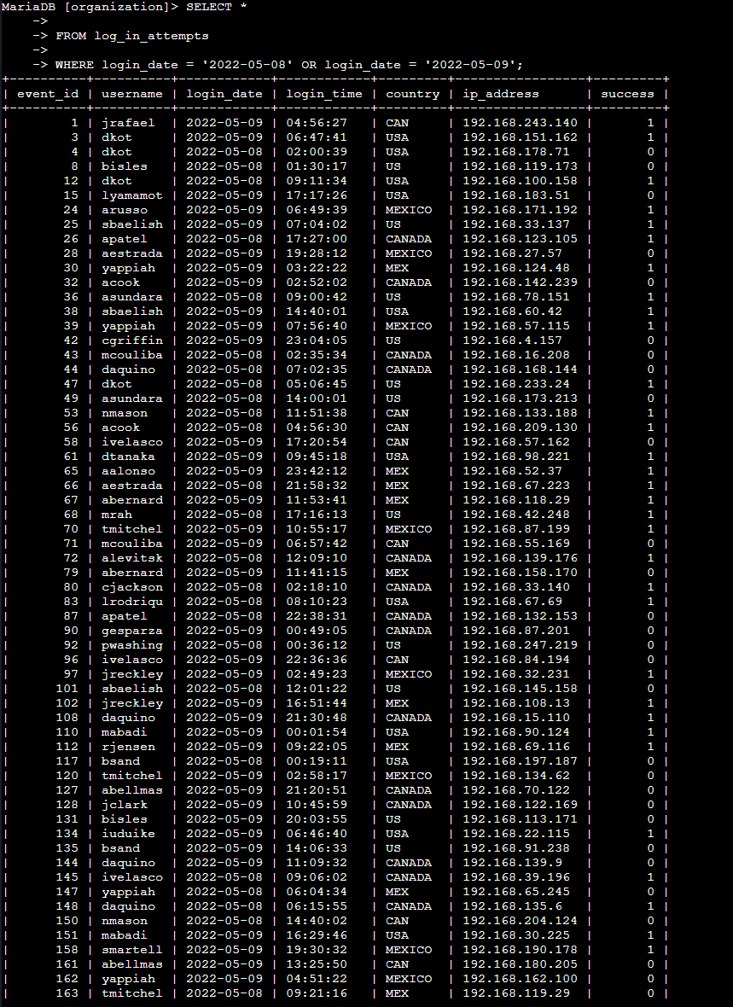

This query retrieves all log in attempts on these 2 dates. I first started by selecting all data from the log_in_attempts table again. Then, I used a WHERE clause with a OR operator to filter the results to output only login attempts on those 2 dates, using the login_date = '2022-05-09' and login_date = '2022-05-08' conditions.

Retrieve login attempts outside of Mexico
After further investigation on login attempts, it was determined that the issue came from countries outside of Mexico. The following demonstrates how I filtered SQL to only give me login attempts outside of Mexico.
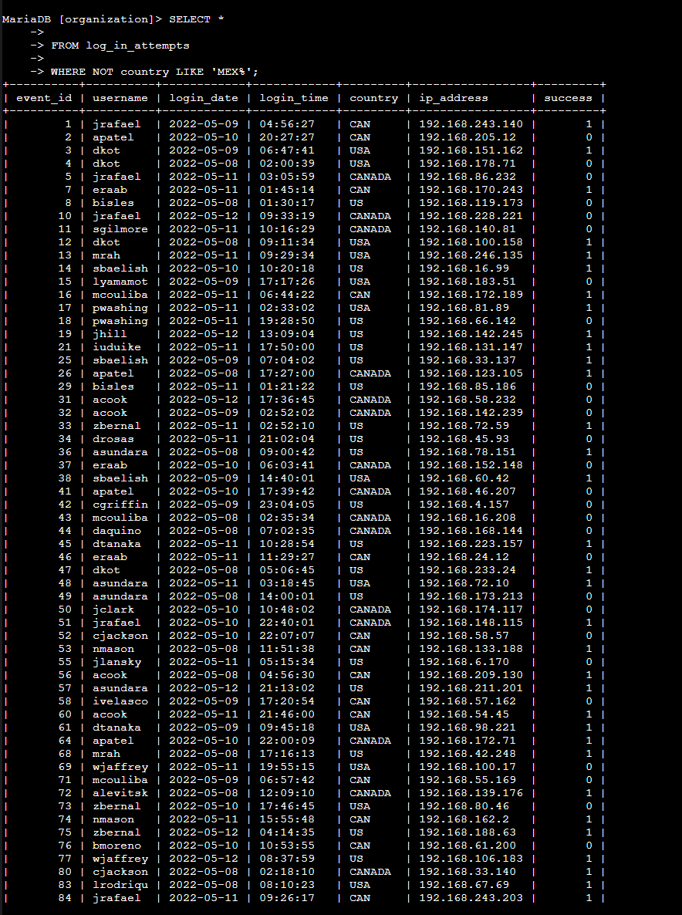

The query and then output is in my above screenshot. Same as before, I started by selecting all data in the log_in_attempts table. I then filtered by using the WHERE and NOT to filter for all countries besides Mexico.Because the data has Mexico as both MEXICO and MEX, I used the LIKE and %. This will account for both versions of how the country is listed.

Retrieve employees in Marketing
The organization wants to update computers in the Marketing department. So to get this information, I used the following SQL query:
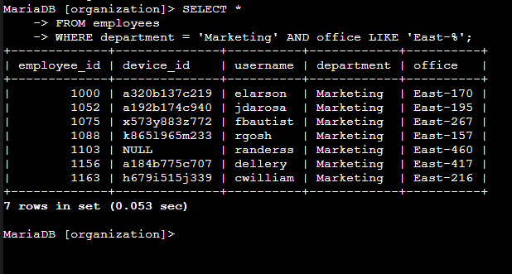
I started by selecting all data in the employees table. Then I used the WHERE clause to filter by Marketing department. Since we’re upgrading employees specifically in the East building, I set office to LIKE ‘East-%’ . This will filter for any employees who are in the Marketing department, and have offices in the East building.

Retrieve employees in Finance or Sales
The machines in Sales and Fincance are also due to be updated. So I created the following SQL query to retrieve all employees who works in those departments:
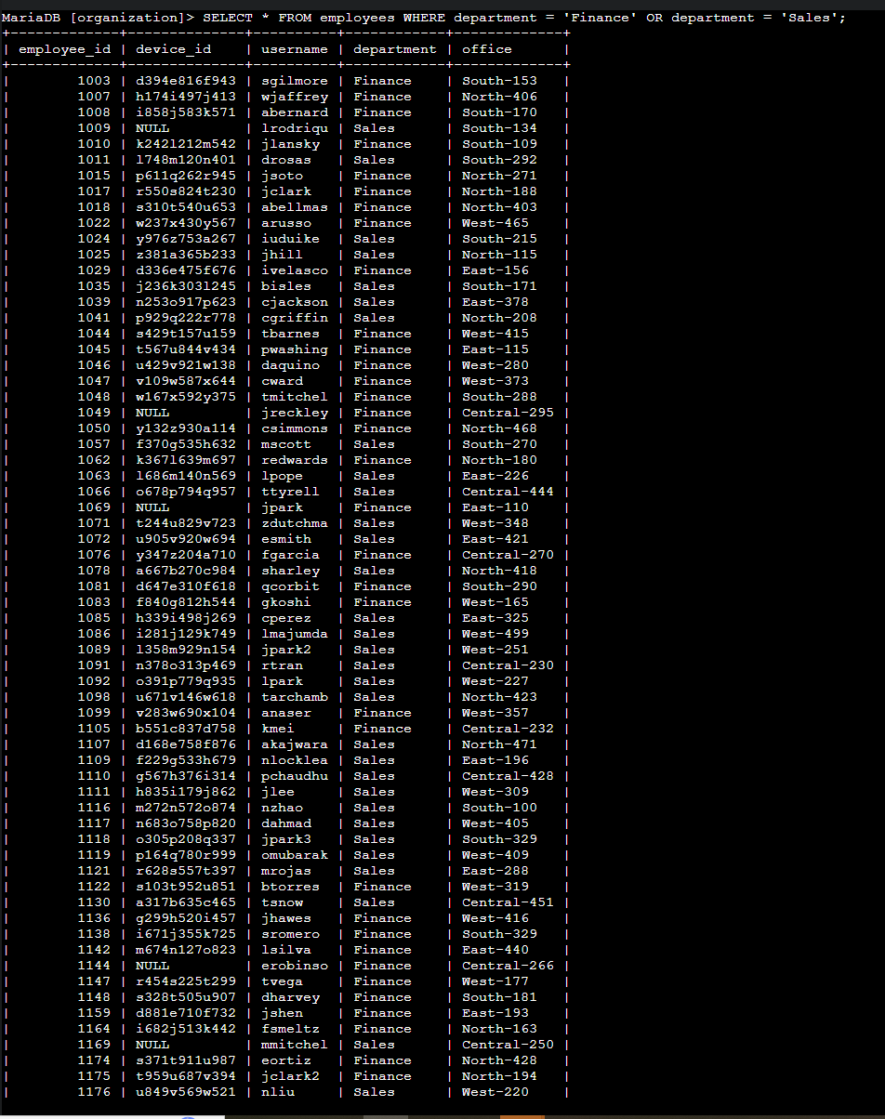
I started by simply selecting all data from the employees table. Then I used the WHERE clause and OR operators to filter for both Finance and Sales. This query will return any employee who meets either of those conditions.

Retrieve all employees not in IT
I need to make one last update for anyone not in the IT department. So I built the following query to retrieve all employees who are not in IT.
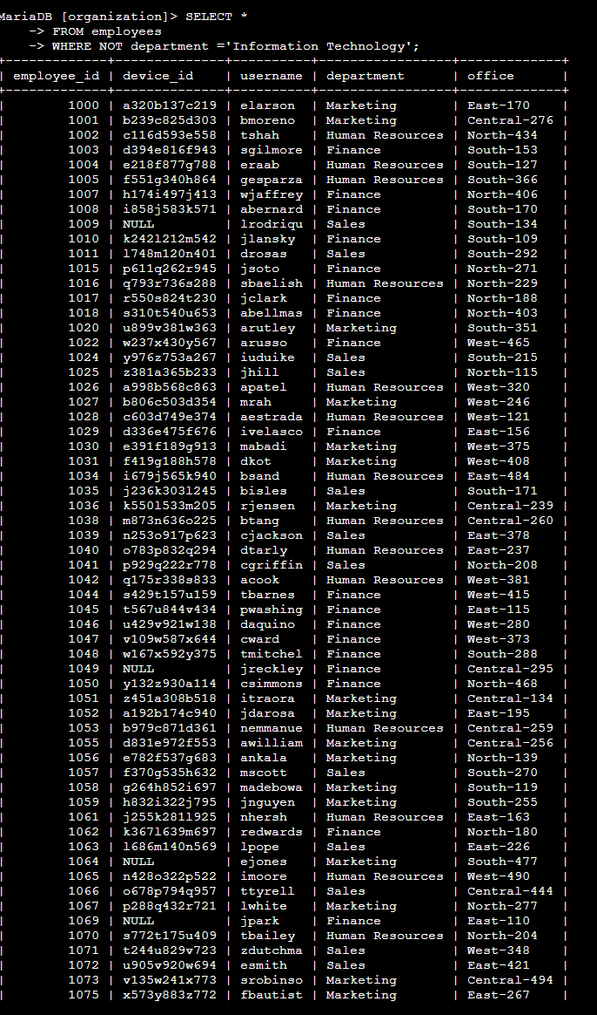
Same as before, I started by selecting all data from employees table. Then I used the WHERE and NOT clauses to filter for anyone not in the Information Technology department.

Summary
I was able to use SQL queries to get specific information that I needed from both the login attempts and the employees tables. I was also able to use AND, NOT, and OR operators to filter down the information to exactly what I needed for each task, as tables can have large amounts of data. Finally, I also was able to use the LIKE and % wildcards to filter for specific patterns, such as for different ways of listing a country.

